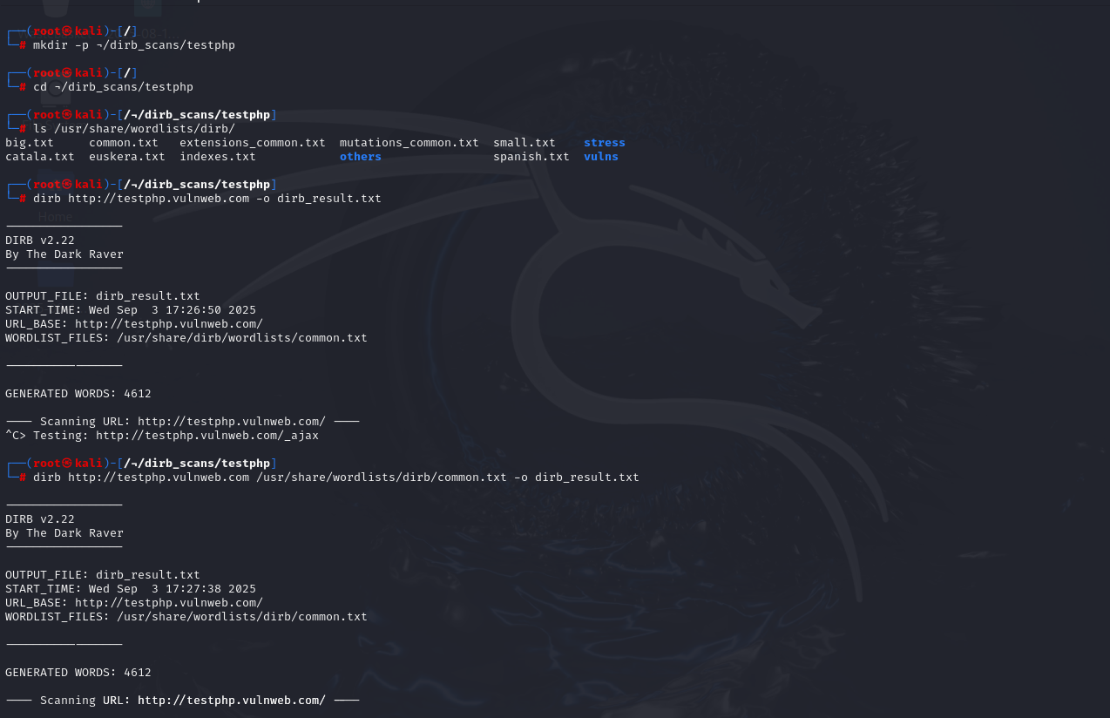

mkdir -p ~/dirb_scans/testphp  
Creates the directory ~/dirb_scans/testphp. -p makes parent directories as needed.

Ls is to check the list of directories and files

Target= testphp.vulnweb.com and -o is to save results of scan into dirb_result.txt

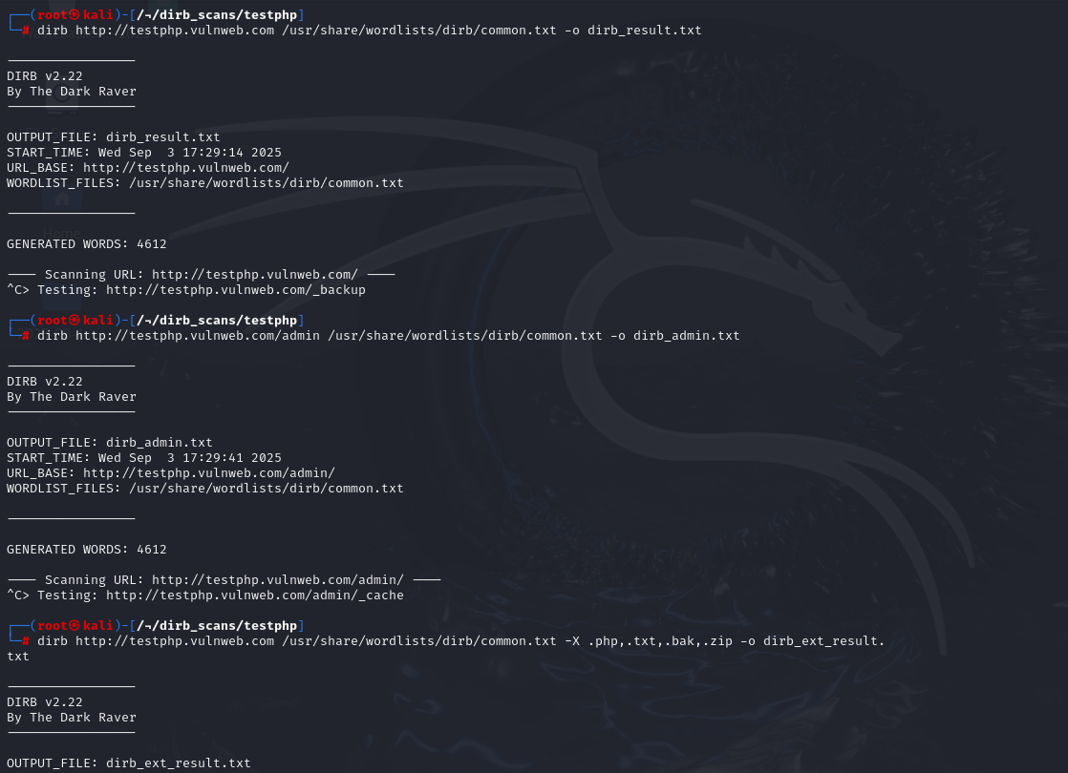

/usr/share/wordlists/dirb/ → This is the **path** where Kali Linux store **Dirb’s default wordlists**.

Perform scan on default admin directory in dirb and storing result in dirb_admin.txt

deeper enumeration for particular extensions and saving result in dirb_ext_result.txt

